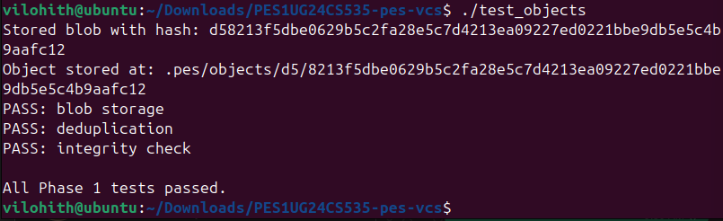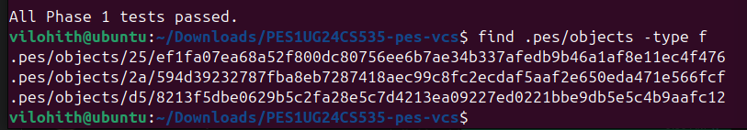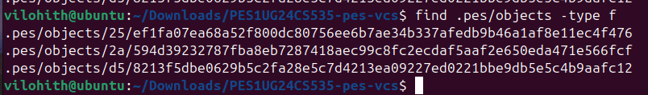

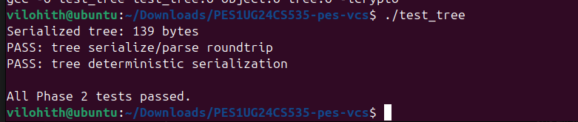

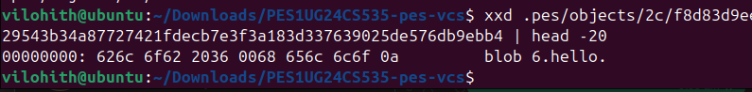

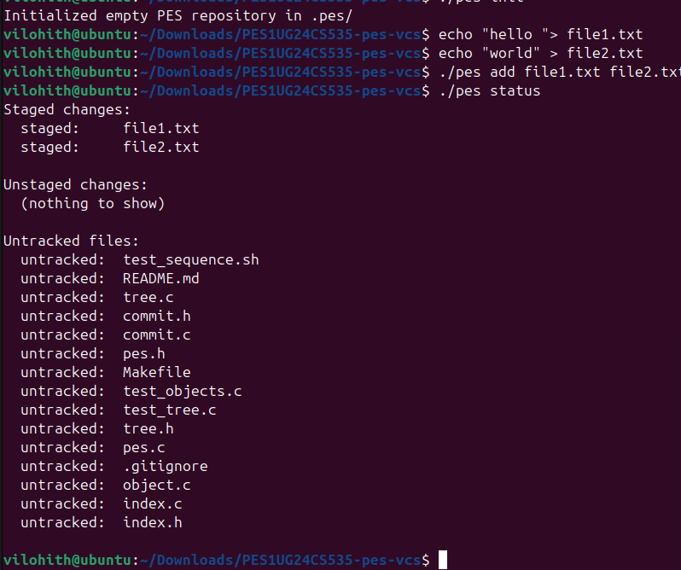
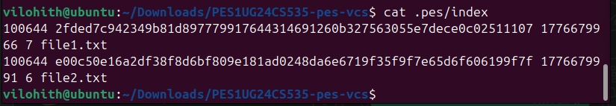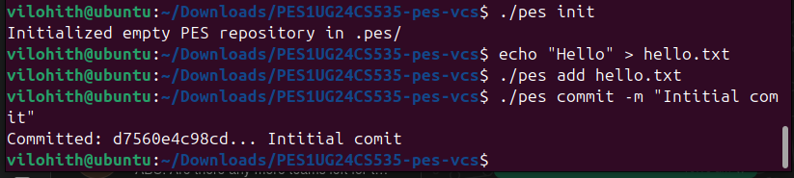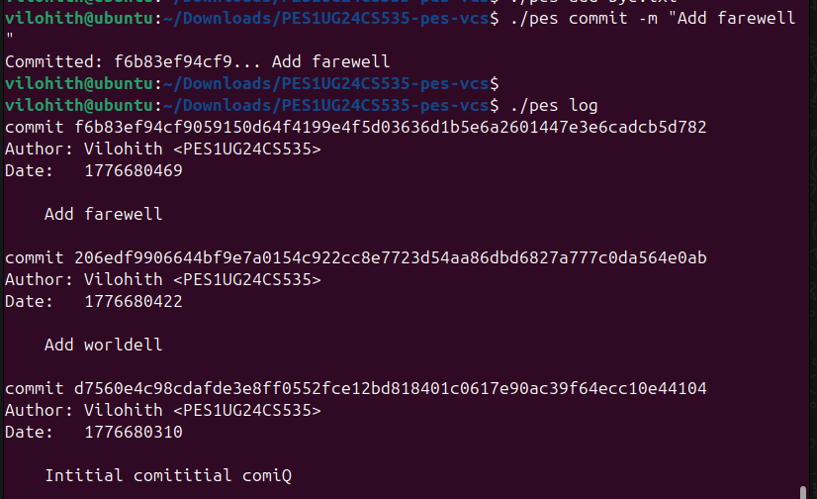

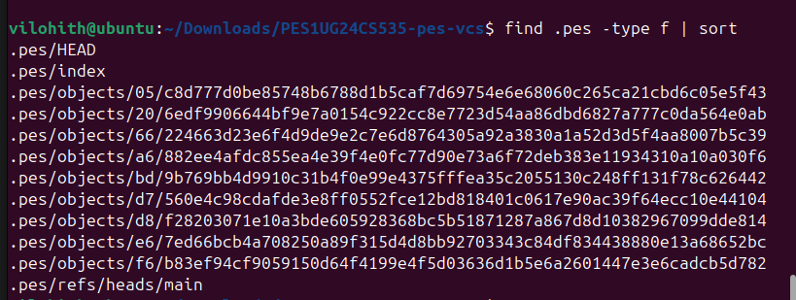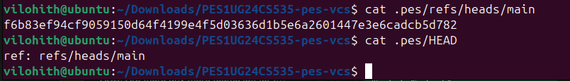

ANS FOR QUESTIONS

Q5.1 — How to implement pes checkout <branch>?
To checkout a branch, three things need to change in .pes/: HEAD must be updated to point to the new branch (e.g. ref: refs/heads/newbranch), and the working directory files must be updated to match the target branch's tree. You'd read the target branch's commit, get its tree, then for every file in that tree write it back to disk. What makes it complex is handling files that exist in the current branch but not the target — those need to be deleted. Also nested subdirectories need recursive handling.

Q5.2 — Detecting dirty working directory conflicts?
Load the current index and compare each entry's stored mtime and size against the actual file on disk using stat(). If any file that differs between the two branches has been modified (mtime or size mismatch between index and working directory), refuse the checkout and tell the user. This is exactly the fast-path diff that index_status already does — no re-hashing needed.

Q5.3 — Detached HEAD?
In detached HEAD state, HEAD contains a raw commit hash instead of ref: refs/heads/branchname. Any new commits you make update HEAD directly but no branch pointer moves. If you then switch branches, those commits become unreachable — no branch points to them. To recover them, you'd need to know the commit hash (from terminal history or reflog) and run pes checkout -b newbranch <hash> to create a branch pointing to them before they get garbage collected.

Q6.1 — Garbage collection algorithm?
Start from all branch refs in .pes/refs/heads/. For each, walk the commit chain following parent pointers, collecting every commit hash. For each commit, read its tree and recursively collect all tree and blob hashes. Store all reachable hashes in a hash set. Then scan every file in .pes/objects/ and delete any whose hash is not in the set. For 100,000 commits with 50 branches you'd need to visit roughly all 100,000 commits plus all their trees and blobs — potentially millions of objects total.

Q6.2 — GC race condition?
Suppose a commit operation has just written a new blob to the object store but hasn't yet written the tree or commit that references it. At that exact moment GC runs, scans all refs, finds the blob is unreachable (no commit points to it yet), and deletes it. Now when the commit operation tries to write the tree referencing that blob, the blob is gone and the commit is corrupt. Git avoids this by giving objects a grace period — any object newer than a certain age (default 2 weeks) is never deleted by GC, ensuring in-progress operations always finish before their objects become eligible for collection.

